

Requirements Document

Serdachny Hockey iOS Mobile App

Prime Software

University of Regina

2020

Table of Contents

1 Introduction 1

1.1 Purpose 1

1.2 Rationale 1

1.3 Vision 1

1.4 Constraints 2

2 Functional Requirements 2

2.1 MVP’s 2

2.2 Context Diagrams 3

2.3 User Requirements 3

2.4 Data Flow Diagrams 3

2.5 Interface Requirements 3

2.6 Other Requirements 3

3 System Requirements 3

3.1 Hardware/ Software Requirements 3

3.2 Operational Requirements 3

3.3 Security Provisions 3

# Introduction

## Purpose

We are attempting to develop an iOS-based mobile management platform that will combine media and marketing capabilities including free development videos and a quick redirect to our customers’ existing online registration content management system that is a web-based application. In addition, we are attempting to upgrade a hockey training system to a dynamic user account configuration including capturing, storing, and modifying video content all within the application.

## Rationale

Our rationale for using an iOS development workflow was due to our customer wanting the initial product release to be seamlessly integrated into existing technologies within their company. This was a main design consideration because of our customers pre-existing hardware that is used in their current hockey analysis ecosystem is mostly comprised of apple products such as iPhones and iPads. Furthermore, the customer has ambitions to further develop the application into a system where they could take advantage of native hardware such as cameras and sensors to perform task such as machine learning and augmented reality to expand the analysis functionality. Due to Apple having pre-existing frameworks designed in the development pipeline; it will allow for the app to scale forward in the future and grow with the customers needs.

## Vision

Our project vision is to apply the Minimum Viable Product model coupled with an agile approach in software engineering. This is guiding us to provide functional software at every point in project deliverables. We are carefully designing and implementing the ability to scale as well as keeping the consideration of security a top priority.

## Constraints

The Constraints for this project are as follows:

1. Learning the software for the first time
   1. XCode, Swift, AWS(Amazon Web Services)
2. Limited Time Frame
3. Limited Initial Budget
4. Must have an Apple computer

# Functional Requirements

We are attempting to provide functional, secure and tested software that the user can apply and improve the systems within Serdachny Hockey to benefit both the company in terms of marketing and business development. This will in turn improve customer experience by adding another level of training functionality. The overall engineering management practice consisted of using agile product development. It implements an iterative approach to deliver a project throughout its life cycle.

## MVP’s

The required approach for project management is to use MVP’s for project development. We will be using an online software tool called Monday.com to act as our project manager and synchronize all our group members with individualized task.

* MVP #1 – User interface, UI functionality, UI testing, Backend pipeline configuration, and basic account signup/ login
* MVP #2 – Fix any issue from MVP #1, Complete user account functionality(Video analysis, modification of media content), and a complete system test with rigorous security test.
* MVP #3 – This would be under the future work section with conversations considering using advanced topics like Machine Learning and Augmented Reality. For the machine learning aspect, I am also working on a proof of concept in another ENSE class project presented by Dr. Yow.

## Context Diagrams

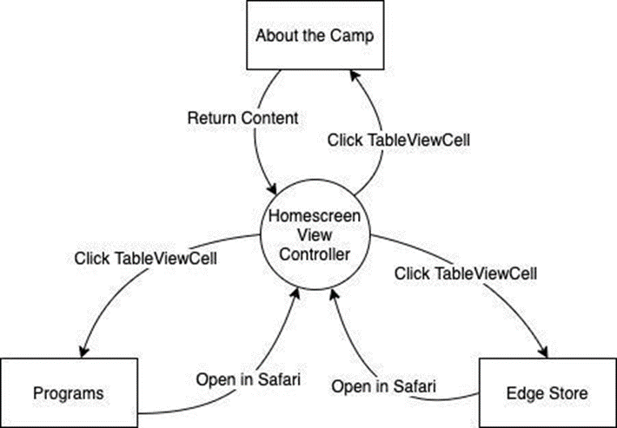

**Fig.1** . Home Screen Context Diagram

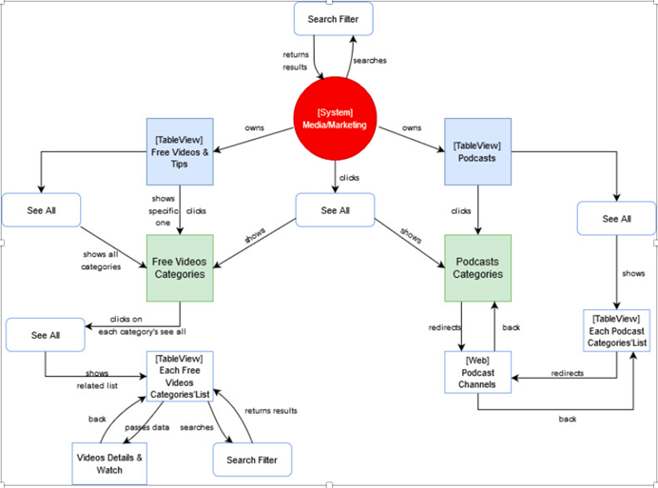

**Fig. 2** Media Screen Context Diagram

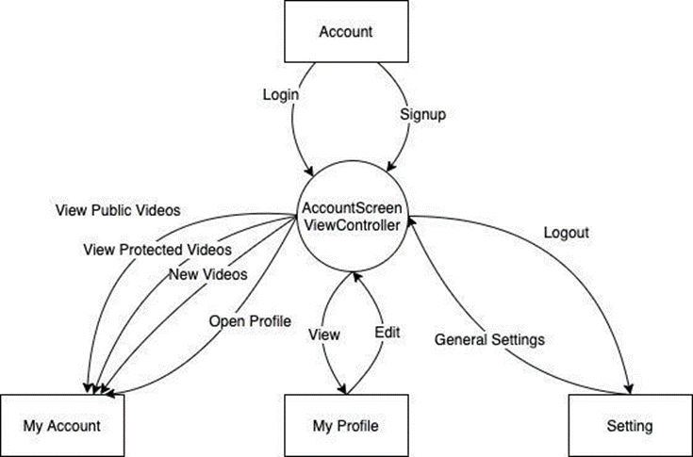

**Fig.3** Account Screen Context Diagram

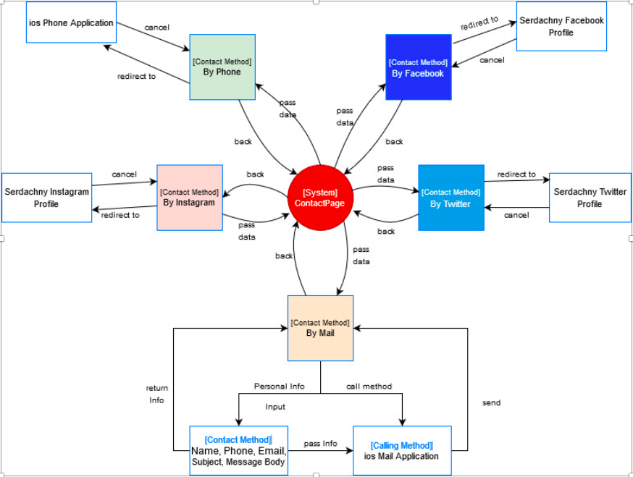

**Fig.4** Contact Screen Context Diagram

## User Requirements

**Home Screen**

|  |  |
| --- | --- |
| **[Req #]** | **Title** |
| Req #1 | The application shall allow the user to view the introduction of the camp. |
| Req #2 | The application shall allow the user to view the programs provided by the camp. |
| Req #3 | The application shall allow the user to purchase the items sold by the camp. |

**Media Screen**

|  |  |
| --- | --- |
| **[Req #]** | **Title** |
| Req #1 | The application shall allow the user to browse the free videos & podcasts |
| Req #2 | The application shall allow the user to click the video contents for viewing the details or watching videos. |
| Req #3 | The application shall allow the user to view all videos & podcasts category |

**Account Screen**

|  |  |
| --- | --- |
| **[Req #]** | **Title** |
| Req #1 | The application shall allow the user to create a new account. |
| Req #2 | The application shall allow the user to login using the created account. |
| Req #3 | The application shall allow the logged in user to view and modify the profile. e.g., avatar, name, ID, etc. |
| Req #4 | The application shall allow the logged in user to view the public video category. |
| Req #5 | The application shall allow the logged in user to view the protected video category. |
| Req #6 | The application shall allow the logged in user to post new videos. |
| Req #7 | The application shall allow the user to go to the settings menu. |
| Req #8 | The application shall allow the logged in user to log out the current account via setting menu. |

**Contact Screen**

|  |  |
| --- | --- |
| **[Req #]** | **Title** |
| Req #1 | The application shall allow the user to view the contact information of the camp |
| Req #2 | The application shall allow the user to contact the camp or leave feedback message |

## Data Flow Diagrams

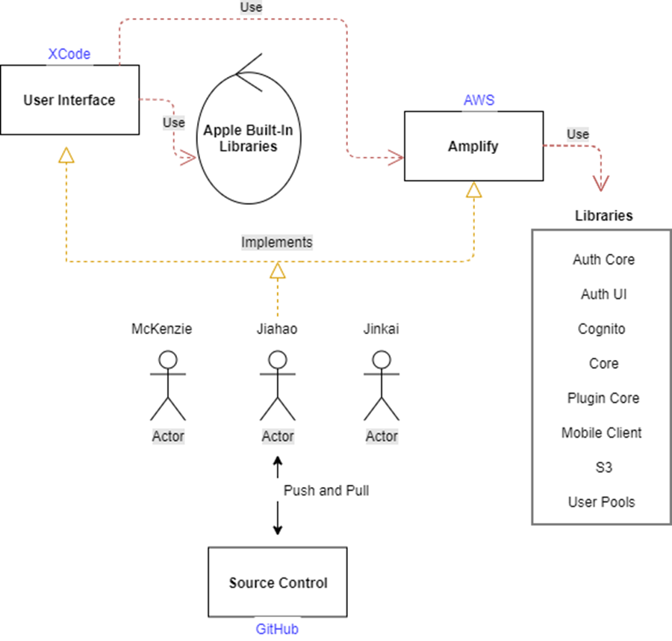

## Interface Requirements

Home Screen

|  |  |
| --- | --- |
| [Req #] | Title |
| Req #1 | List of programs visible in the program table view. |
| Req #2 | List of store items visible in the edge store table view. |
| Req #3 | Table cell item clickable. |
| Req #4 | About the camp view is clickable on the home screen. |
| Req #5 | About the camp view visible on the home screen. |

Media Screen

|  |  |
| --- | --- |
| [Req #] | Title |
| Req #1 | List of videos and podcasts visible in the table view. |
| Req #2 | Table cell item clickable. |
| Req #3 | Details of each content should be passed to other views |
| Req #4 | Free videos can be watched in the view |
| Req #5 | Enable search filter for videos |

My Account

|  |  |
| --- | --- |
| [Req #] | Title |
| Req #1 | Login and Signup Button |
| Req #2 | Visualize the login and signup form, ensure the user has access to the form. |
| Req #3 | Button for login |
| Req #4 | Button for signup |
| Req #5 | Button for change the password |

Contact Screen

|  |  |
| --- | --- |
| [Req #] | Title |
| Req #1 | Camp contact info visible |
| Req #2 | Optional ways to contact camp |
| Req #3 | Contact methods clickable. |

## Other Requirements

Home Screen

|  |  |
| --- | --- |
| [Req #] | Title |
| Req #1 | The “Program Table View” shall ensure that the program info can be retrieved from the program array. |
| Req #2 | Users shall be directed to the corresponding program detail web page by clicking the program cells. |
| Req #3 | The “Edge Store Table View” shall ensure that the item info can be retrieved from the edge store array. |
| Req #4 | Users shall be directed to the corresponding item detail web page by clicking the item cells. |

Media Screen

|  |  |
| --- | --- |
| [Req #] | Title |
| Req #1 | The “Free Video Table View” shall ensure that the program info can be retrieved from different video category arrays. |
| Req #2 | Users shall be directed to the corresponding video details page by clicking the video cells. |
| Req #3 | Users shall be directed to the corresponding podcast detail page by clicking the podcast cells. |

Account Screen

|  |  |
| --- | --- |
| [Req #] | Title |
| Req #1 | The AWS Authentication system shall ensure the user can create a new account. |
| Req #2 | The AWS Authentication system shall ensure the user can log in to the application. |
| Req #3 | Only logged in user can retrieve the videos from the AWS S3 bucket. |
| Req #4 | Only logged in user can modify the profiles. |
| Req #5 | About the camp view visible on the home screen. |

Contact Screen

|  |  |
| --- | --- |
| [Req #] | Title |
| Req #1 | The “Contact Static View” shall ensure that the camp info(at least email contact) can be displayed from the view controller. |
| Req #2 | Users shall be able to contact company in specific ways |

# System Requirements

## Hardware/ Software Requirements

The hardware needed to use the app is any Apple Mobile device such as iPhone or iPad. Currently the system is backward compatible to the iPhone 4 model. Along with using an Apple product the software used for the system will be available on the App store for public download.

## Operational Requirements

The system is intended to scale with the user rate of use. This means as the number of users increases the system must accommodate the growth. The overall reliability of the system must provide seamless functionality for users due to the real time analysis of an individual's training progression.

## Security Provisions

The following consequences of security breaches for the application must be at all cost be avoided:

1. Loss or corruption of data
2. Disclosure of secrets or sensitive information
3. Disclosure of privileged/privacy information about individuals
4. Corruption of software or introduction of malware, such as viruses

The type(s) of security required. Include the need for the following as appropriate:

1. Physical security.
2. Access by user role or types.
3. All users have permission to view the home screen, media, and contact section but not update it.
4. All users (once created an account) will have access to view, update, and delete personal data, but not others.
5. Company administrators can create, edit and remove all user’s information on a case by case basis.
6. There is a need for certification and accreditation of all security measures that ownership must grant.

# Additional Requirements Post Capstone

## Design

## Functionality

## Security

## Testing